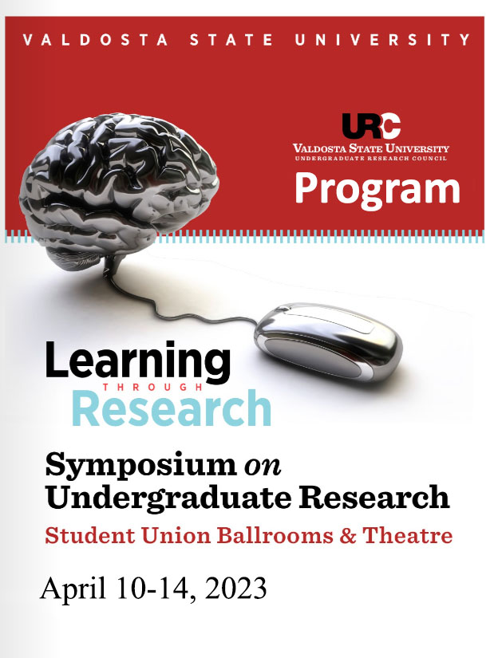

Monday April 10th
^{Beginnings}
Celebrate our VSU Freshman Scholars
3:00 pm Opening
https://www.valdosta.edu/urc/

First-Year Freshman Learning Communities (FLCs) provide students an opportunity to begin their college experience with other students who share similar interest and career objectives. This video project represents the first steps into research at the university level. Congratulations Scholars!

Tuesday April 11th
Oral Presentations
On-Site
Student Union Theater

9:30-10:45

Moderator: Dr. Anne Price, Department of Sociology, Anthropology and Criminal Justice

10 Key Evidence-Based Practices to ensure Developmentally Appropriate Practices in
Elementary Education

Tranayah U. Clark
Sponsor: Dr. Forrest Parker
James L. and Dorothy H. Dewar College of Education and Human Services,
Teacher Education

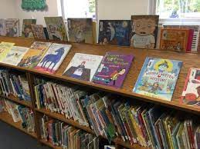

Accelerating Cancer Growth Rates to Kill Cancer Cells

Akshil Patel and Capri Persaud
College of Science and Mathematics, Chemistry
Sponsor: Dr. Tom Manning

Achievement and Social-Emotional Differences between Boys and Girls
Tammy J. Byrd
Sponsor: Ophelie Desmet
James L. and Dorothy H. Dewar College of Education and Human Services,
Human Services

A Consideration of Work Morale's Deeper Impact

Andrew J. Bardes
Sponsor: Dr. Chialing Ho
College of the Arts, Communication Arts
11:00-12:15

Moderator: Dr. Michael Eaves, Department of Communication Arts

The Florida Panhandle: Coastal Property Values

Alexandra Elizabeth Redfearn
Sponsor: Dr. Zulal Denaux
Langdale College of Business Administration, Economics/Finance and Healthcare Administration

Predicting the African Penguin Population Using Mathematical Models

Crishawn Tyrik Monroe
Sponsor: Dr. Andreas Lazari
College of Science and Mathematics, Mathematics

A Hate It or Love It Relationship with Dharma & Greg and
Its Pragmatic Analysis

Tammy L Cochran
Sponsor: Dr. Li-Mei D. Chen
College of Humanities and Social Sciences, English

A Musical Realization of the Aramaic Version of The Lord's Prayer

Zackary David Price
Sponsor: Dr. Joshua Pifer
College of the Arts, Music

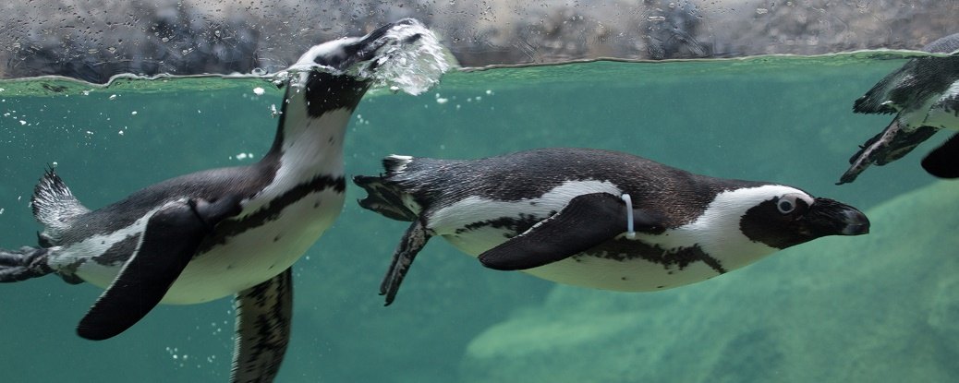

1:00-1:50

Moderator: Dr. Charles Talor, Department of Psychological Sciences

An Exercise in Hashing

Michael Cartier, Megan Johnson and Candace Williams
Sponsor: Dr. Anurag Dasgupta
College of Science and Mathematics, Computer Science

Are Morphological Traits of the Dwarf Seahorse (Hippocampus zosterae)
Under Selection Due to the Mating Pressure?

Darshi N Patel
Sponsor: Dr. Emily Rose
College of Science and Mathematics, Biology

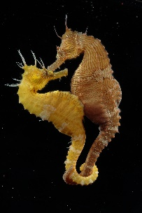

The Use of Dating Apps Compared to the Ease of Finding a Partner

Claudia R. Brown
Sponsor: Dr. Chialing Ho
College of Arts, Communication Arts

2:00-3:15
Spotlight:
Teagle Program

Moderator: Mr. B. Cordell Moats, Department of History

Teagle Student’s Service-Learning Presentations “College Readiness through Civic Engagement” VSU Knowledge for Freedom Program
(Funded by the Teagle Foundation)

Co-Coordinators: Dr. Joseph Robbins and
Dr. Neena Banerjee

Civic Engagement Project on Food Insecurity
Donovan Duncan, Valdosta Early College Academy
Tylin Dyer, Valdosta High School
Joshua Kim, Lowndes High

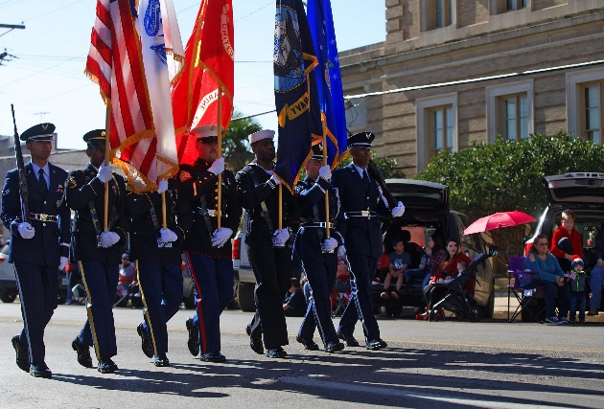

Civic Engagement Project on Homeless Veterans
Briana Johnson, Valdosta High School
Dilan Mendez-Garcia, Berrien High
Jeremy Seals, Brooks County High School
Shaniya Eaford, Lowndes High School

Civic Engagement Project on Teen Mental Health
Joi Beaulieu, Cook County High School
Caldreonna Berrian, Valdosta Early College Academy
Rokita Spencer, Cook County High School
Zykira Stallworth, Valdosta Early College Academy
Lonyea Williams, Valdosta High School

3:30-5:00
Debate

Moderator: Dr Michael Eaves, Department of Communication Arts

“China is a greater threat to the U.S than Russia”

Pro: Josh Julian, senior, mass media
Con: Reagin Jones, sophomore, political science
Speaker of House, Stephania Ortez, comm arts

6:00-7:30
Student Union Theater

Moderator: Dr. Tom Aiello,
Department of History

“Conducting Research on the
Civil War from the Perspective
of an Outsider”

Piotr Derengowski
University of Gdansk

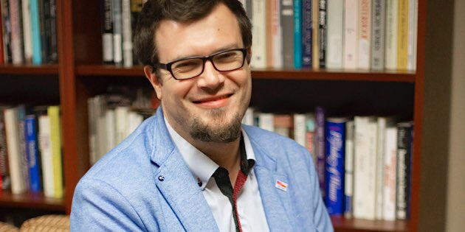

Piotr Derengowski (History, University of Gdańsk, Poland). MA in History, University of Gdańsk (2006). Published more than twenty articles, as well as four bios in The Polish American Encyclopedia (2011) and one bio in Polski Słownik Biograficzny. Polish-American Research Fellowship (Garstka Program) at the Notre Dame University, 2010–2012. PAHA’s Graduate Student Research Paper Award (2013) for an article: “Capt. Alexander Raszewski's Polish Legion and Other Less Known Polish Troops in the Union Army During the American Civil War“. PhD in History, University of Gdańsk (2014). Dissertation title: “Poles in the American Civil War 1861–1865”. Teaching Fellowship from the Kosciuszko Foundation at SUNY Buffalo, 2014-2015. Louis Brown scholarship at the Valdosta State University (Spring Semester 2019, and 2023). Currently works as an Assistant Professor at the University of Gdańsk, Institute of History (since 2017). Research interests: Polish immigration in the United States after 1831, military history, U.S. Civil War, U.S. Colored Troops, racial discrimination in the US Army from the Civil War to the War in Korea. ORCID: https://orcid.org/0000-0002-4414-0545
Wednesday April 12th
Oral Presentations
On-Site
Student Union Theater

8:00-8:50

Moderator: Dr. Glenda Swan, Department of Art and Design

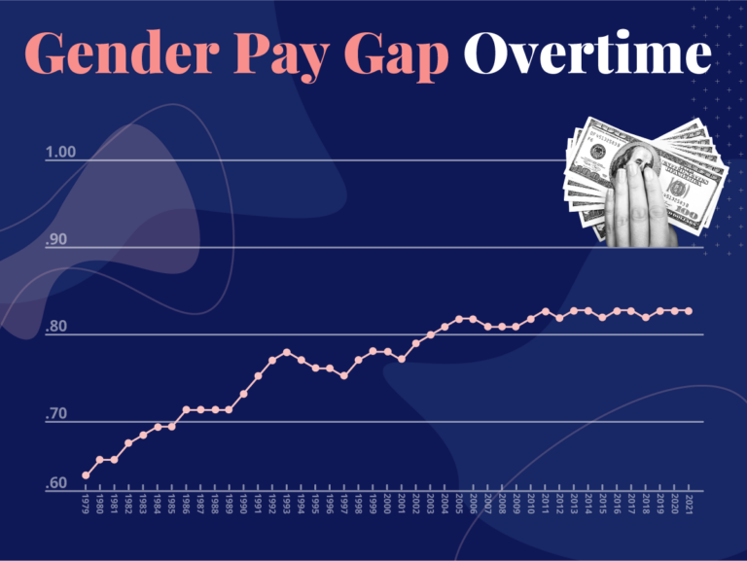

Wage Gap in the United States: What Factors Explain the Pay Gap between Men and Women
Across the 50 States?

Abigail G. Wilcher
Sponsor: Dr. James LaPlant
College of Humanities and Social Sciences, Political Science

Effects of Silver on Respiration of Baker's Yeast

Julia Higdon
Sponsor: Dr. Kurt Winkelmann
College of Science and Mathematics, Chemistry

Twice Exceptionality:
The Profile of Developmental Coordination Disorder and Giftedness

Jamaceo Rhodes
Sponsor: Dr. Ophelie Desmet
James L. and Dorothy H. Dewar College of Education and Human Services,
Human Services

9:00-9:50

Moderator: Dr. Sarah FitzGerald, Department of History

Bach's Double Violin Concerto in D Minor, BWV 1043, I. Vivace

Amelia Pharis, Kamille McLean and Rebeca Sierra
Sponsors: Dr. Joshua Pifer and Xin Yu Chang
College of Arts, Music

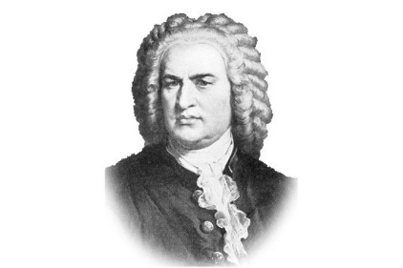

Bicycle- and Pedestrian-Involved Crashes: Investigating Causes and
Solutions in South Georgia

Nikki Ballard, Erica Glover, Autumn McAtee and Nashie Wesley
Sponsors: Dr. Brandon Atkins and Dr. Anne Price
College of Humanities and Social Sciences, Sociology, Anthropology and Criminal Justice

Cleopatra: An Ancient Story for a 1960s Audience

Hannah M. Clark
Sponsor: Dr. Melanie Byrd
College of Humanities and Social Sciences, History

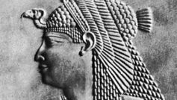
10:00-10:50

Moderator: Dr. Glenda Swan, Department of Art and Design

Developmentally Appropriate Practices in the Elementary Classroom

Martha Breedlove
Sponsor: Dr. Forrest Parker
James L. and Dorothy H. Dewar College of Education and Human Services,
Teacher Education

Discovering Unique Strengths of Students with Autism Spectrum Disorder

Jenna N. Herren
Sponsor: Dr. Ophelie Desmet
James L. and Dorothy H. Dewar College of Education and Human Services,
Human Services

Discovery of Copper-Catalyzed Click Chemistry Reaction Intermediates in
Nanoreactor by Accelerated MD

Walker Hayes
Sponsor: David Shafat Mubin
College of Science and Mathematics, Physics, Astronomy, Geoscience
and Engineering Technology

11:00-11:50

Moderator: Dr. Anne Price, Department of Sociology, Anthropology and Criminal Justice

Dissecting the Signaling Network of Plant Defense Hormone, Methyl jasmonate

Daniel Rincon Diaz
Sponsor: Dr. Ansul Lokdarshi
College of Science and Mathematics, Biology

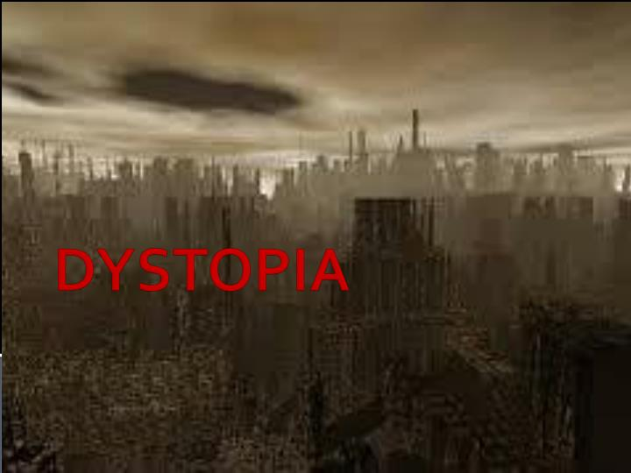

When Real-Life Horror Meets Fiction: Dystopia in The Nickel Boys

Laura A. Northup
Sponsor: Dr. Donna Sewell
College of Humanities and Social Sciences, English

On-Campus Greenspaces and Student Mental Health in Conjunction with Landscape Genetics

Nicole E. Woolridge
Dr. Shelly Yankovskyy
College of Humanities and Social Sciences, Anthropology
College of Science and Mathematics, Biology

12:00-12:50

Pizza Lunch for Presenters and Sponsors
Student Union Ballrooms

1:00-1:50 PM

Spotlight: Chemistry
Moderator: Dr. Lavonna Lovern, Department of Philosophy and Religious Studies

Monkeypox, Cowpox and Covid:
VSU Students the National Institute of Health and Book Chapters

Justin Arrington, Robert T. Smith, Akshil Patel,
Capri N. Persaud, Teighlor Livingston,
Madelyn R. Adair, Taylor L. Taylor
Sponsor: Dr. Tom Manning

The results came back from the National Istitute of Health (NIH). In both cases we exceeded the standard treatments. The top summary is against the variola virus (smallpox virus). In the notes we had several highly active compounds (they are similar but with different geometries - which can impact efficacy). This virus is of concern because of bioterrorism. It was officially eradicated in 1970's. However, between 1900 and 1975 it killed 300 million people. The bottom virus (Cowpox) had one of our compounds moderately active. We will spend time examining the results/data. We submitted 12 variations of our structures for each virus so this was not a simple single data point but a way of looking for trends. These same students are working on an invited book chapter for our COVID work during the pandemic.
2:00-2:50

Moderator: Dr. Lorena Aquirre Salazar, Department of Mathematics

Extraction of Carotenoids Using Non-ionic Deep Eutectic Green Solvents

Lizett Rubio
Sponsors: Dr. Gopeekrishnan Sreenilayam and Dr. Ligia Alexandrina Focsan
College of Science and Mathematics, Chemistry

Heteronormativity and Compulsory Heterosexuality

Carlyn A. Remmes
Sponsor: Dr. A.J. Ramirez
College of Humanities and Social Sciences, Women's and Gender Studies

Factoring in Violent Crime

Maleigh R. Arnold
College of Humanities and Social Sciences, Political Science

3:00-3:50

Moderator: Mr. B. Cordell Moats, Department of History

House Bill 1084 and Cultural Education in Georgia

Devon L. Day
Sponsor: Dr. Karen Terry
James L. and Dorothy H. Dewar College of Education and Human Services,
Teacher Education

Evidence-Based Practices for Managing the Elementary Classroom

Cassidy Huebener
Sponsor: Dr. Forrest Parker
James L. and Dorothy H. Dewar College of Education and Human Services,
Teacher Education

Religion, Gender, and Regretful Sexual Experiences

Zy'Ronica S. Lindsey
Sponsor: Dr. Anne Price
College of Humanities and Social Sciences, Sociology, Anthropology, and Criminal Justice

4:00-4:50

Moderator: Dr. Ahana Roy Choudhury, Department of Computer Science

Is Homosexuality a Choice: An Examination of Biological
Factors Contributing to Homosexuality

Damon Negron
Sponsor: Dr. A.J. Ramirez
College of Humanities and Social Sciences, Women's and Gender Studies
College of Science and Mathematics, Biology

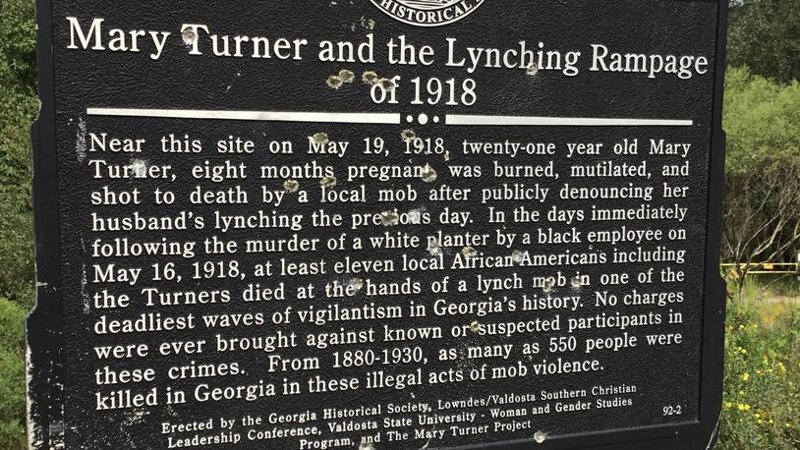

A Look into the Lynching Rampage of Lowndes County:
Why It Happened, and Why It Is Relevant Today

Reagin M. Jones
Sponsor: Dr. Melanie Byrd and Dr. Deborah Davis
College of Humanities and Social Sciences, History

Cervical Cancer and Its Disproportionate Effect on POC Women

Elysse N. Camp
Sponsor: Dr. Andreas Lazari
College of Science and Mathematics, Mathematics

Wednesday 12th
Webinar
On-line
https://us.bbcollab.com/guest/e3949ee149064c7fa1f0461e5b4d7724
9:00-10:45

Moderator: Samantha Paul, MSLIS, Odum Library

What's the Deal with CRT?

Gerardo J. Carter
Dr. Karen Terry Sponsor: Dr. Karen Terry
James L. and Dorothy H. Dewar College of Education and Human Services,
Human Services

Praying in School

Laneston L. Hendricks
Dr. Karen Terry
James L. and Dorothy H. Dewar College of Education and Human Services,
Human Services

I Pledge Allegiance

Courtney N. Clark
Dr. Karen Terry
James L. and Dorothy H. Dewar College of Education and Human Services,
Teacher Education

Education Stance on Gun Violence

Michael T. Addison
Sponsor: Dr. Karen Terry
James L. and Dorothy H. Dewar College of Education and Human Services,
Teacher Education
11:00-12:15

Moderator: Dr. Ubaraj Katawal, Department of English

Experiential Learning Through Tutoring of a Second Language
Apprentissage expérientiel par le biais du tutorat d’une langue seconde

Scot Burbank
Sponsor: Dr. Ofelia Nikolova
College of Humanities and Social Sciences, Modern and Classical Languages

The Gypsies of Spain: A Triumphant Perseverance

Yoav Golan
Sponsor: Dr. Grazyna Walczak
College of Humanities and Social Sciences, Modern and Classical Languages

Women's Reproductive Rights and Effects on Students

Savannah F. Carter
Sponsor: Dr. Karen Terry
James L. and Dorothy H. Dewar College of Education and Human Services,
Teacher Education

Uncovering the Heart of Democracy: An Experiential Journey through a
Legislative Fellowship in Paris

Mathilde Anik Vedel
Sponsor: Dr. Ofelia Nikolova
College of Humanities and Social Sciences, Modern and Classical Languages

Investigating Students' Perspectives on Their College through
Exploratory Data Analysis
Joanna N. Smith, Gerniya Z. Flewellen and Andrew J. King
Sponsor: Dr. Taewon Hwang
Langdale College of Business Administration, Management and Healthcare

3-Minute Video Contest
6:00-7:30 PM
Student Union Theater

Moderator: Dr. Tom Aiello

Traces of Judaism that Spain Couldn’t Expulse: Jewish Influence in the Spanish Culture
Lauren Mariah
Sponsor Dr. Grazyna Walczak: Modern and Classical Languages

Plaque Psoriasis
Sara Taylor
Sponsor: Dr. Tom Manning: Chemistry

Limiting the Ecological Footprint of the Theatrical Industry
Ella Risa Marroquin
Sponsor: Dr. Chalise Ludlow: Theater

How Important Is Artificial Intelligence in the Modern World?
Yasmeen E. Hart
Sponsor: Dr. Jin Wang: Computer Science

The Cost of Healthcare
Chloe Brevaldo, Julia Rafferty and Sara Pirkle
Sponsor: Dr. Michele Blankenship: Nursing and Health Sciences

Producing Educational Videos to Help Local Educators and Schools in the Coastal Plain RESA
Jamie Collins and Chontele Abney
Sponsor: Dr. Collin Walker: Mass Media

Pilot Project for Future Experimental Learning: Building Raspberry Pi Clusters
Walker Hayes and David Joyner
Sponsor: Dr. Zhiguang Xu: Computer Science

Utilization of Non-Ionic Deep Eutectic Green Solvents for Carotenoid Extractions
David Vasquesz
Sponsor: Dr. Gopeekrishnan Sreeilayam: Chemistry

Dissecting the Signal Network of Plant Defense Hormone, Methyl jasmonate
Daniel Rincon Diaz
Sponsor: Dr. Ansul Lokdarshi: Biology

The Shell Game
Kiersten Ley and Reagan Newsome
Sponsor: Dr. Tom Manning: Chemistry

Thursday April 13th
Oral Presentations
On-Site
Student Union Theater

9:30-10:45
Moderator: Dr. Gopeekrishnan Sreenilayam, Department of Chemistry

Not All That Glitters Is Gold: A Critical Reading of Spanish Golden Age Poetry

Georgia J. Wynn
Sponsor: Dr. Grazyna Walczak
College of Humanities and Social Sciences, Modern and Classical Languages

Perception of Shared Autonomous Vehicles in Public Transit

Caroline R. Blanton, Jazmin M. Borges, Destiny A. Adams, Kelis T. Bell, Cooper W. Andolsek,
Mackenzie B. Jones, Kaleb J. Woodruff, John I. Watts, T. Bruch, Grier G. Rogers, Bre'niah T. Hare and Davis T. Baldwin
Sponsor: Dr. Jia Lu
College of Science and Mathematics Physics, Astronomy, Geoscience
and Engineering Technology

Predicting a Mammal's Sleep Pattern Based on a Mammal's Weight

Callie N. Reid
Sponsor: Dr. Andreas Lazari
College of Science and Mathematics, Mathematics

A Mathematical Study of Popular Music

Tristin Sahagun, Caleb Epps and Michael Cartier
Sponsors: Dr. Denise reid and Dr. Lorena Aguirre Salazar
College of Science and Mathematics, Mathematics
11:00-12:15

Moderator: Dr. Michael Eaves, Department of Communication Arts

Predicting the New Number of HIV Cases in Georgia Per Year Using
Mathematical Models

Adasia McClinton
Sponsor: Dr. Andreas Lazari
College of Science and Mathematics, Mathematics

Psychological Effects on Bilingual Children

Laura K. James
Sponsor: Dr. Lavonna Lovern
College of Humanities and Social Sciences, Interdisciplinary Studies

Socioeconomic Status, Mental Health, and Opioid Abuse

Jacob Avila
Sponsors: Dr. Anne Price and Dr. Ellis Logan
College of Humanities and Social Sciences, Sociology, Anthropology and Criminal Justice

Super Shellfish: How Oyster Restoration Can Help Save Our Ocean

Madeline Pond
Sponsor: Dr. Tom Manning
College of Science and Mathematics, Chemistry

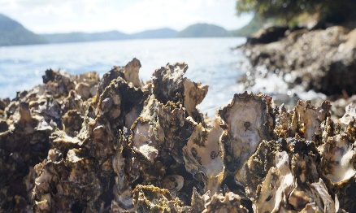

2:00-3:15

Moderator: Dr. Lorena Aquirre Salazar, Department of Mathematics

The Advance of Autonomous Self-Driving Vehicles

Grant D. Lopez and William B. Butterfield
Spnsor: Dr. Chunlei Liu
Department of Science and Mathematics, Computer Science

The Case for Multiculturalism: Developing University and Community
Collaborative Social-Cultural Events

Kiesha Washington
Sponsors: Dr. Ellis Logan and Dr. Anne Price
College of Humanities and Social Sciences, Sociology, Anthropology and Criminal Justice

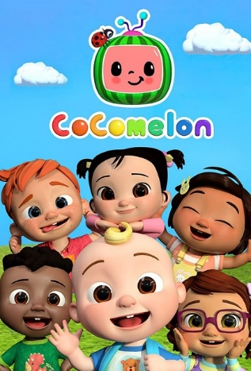

The Cocomelon Effect: The Dangers of Unprecedented Baby Media Consumption

Addeline S. Wright
Sponsor: Leigh Bryan, M.A.
Honors College

The Effect of Brown vs. Board of Education Locally at Valdosta State College
and Lowndes High School

Isabelle F. Reimer
Sponsor: Ms. Deborah Davis
College of Humanities and Social Sciences, History

3:30-4:45

Moderator: Dr. Marc Pufong, Department of Political Science

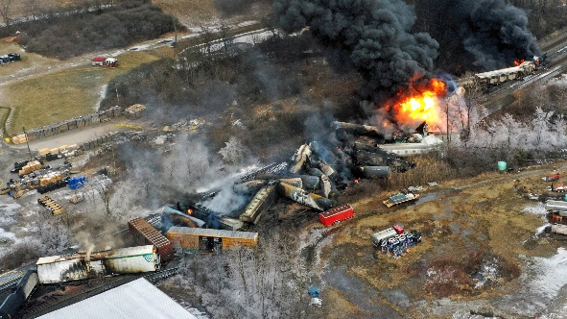

Potential Consequences of the 2023 Ohio Train Derailment on the Progression of Society

Kristal A. Salmon-DePass and Aaliyah J. Chapman
Sponsor: Dr. Phillip Storey
College of Science and Mathematics, Biology

The Mental Health of Collegiate Athletes Due to Athletic Demands

Madeleine Rae Mayer
Sponsor: Dr. Christine A. James
Honors College

The Relation of Online Interaction and Confidence

Nautica N. Graddy
Sponsor: Dr. Chialing Ho
College of the Arts, Communication Arts

Electrochemical CO₂ Reduction Utilizing a Pd-Ni-Cr Trimetallic Catalyst

Jodeci L. Mitchell
Sponsor: Dr. Tolulope Salami
College of Science and Mathematics, Chemistry

Poster Presentations/Reception

Student Union Ballrooms
6:00-7:30

Awards
7:30

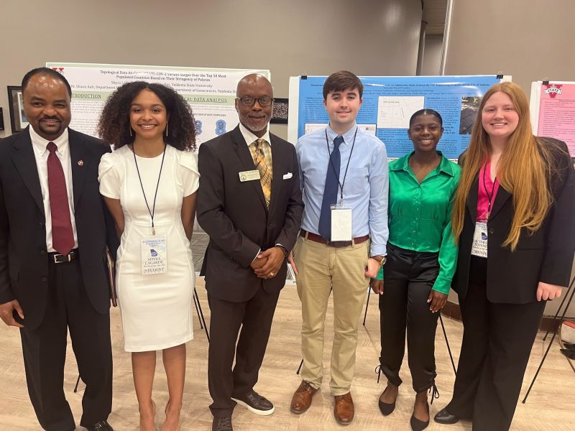

Poster
Participants

2022 Georgia Gubernatorial Race: The Re-Election of Governor Brian Kemp
Sarah D. Burch
Sponsor: Dr. James LaPlant
College of Humanities and Social Sciences, Political Science

Abortion and the Current Political Climate
Tori-Anne S. Chambers
Sponsor: Dr. Anne Price
College of Humanities and Social Sciences, Sociology, Anthropology, and Criminal Justice

Abortion Policy across the 50 States
Colette Lena Ireton
Sponsor: Dr. James LaPlant
College of Humanities and Social Sciences, Political Science

Adverse Societal Effects of Online Gambling
John A. Self, Keegan F. McCartha and Carl B. Hamer
Sponsor: Dr. Sudip Chakraborty
College of Science and Mathematics, Computer Science

Algeria and Civil Governance Today: Democracy, Corruption and Human Rights
Zachary A. Ziady
Sponsor: Dr. Marc Pufong
College of Humanities and Social Sciences, Political Science

A Whole "New Look" or a Whole "New View":
Analysis of the Development of the Aladdin Movie Cultural Garments
Brandall S. Kearse Jr.
Sponsor: Chalise Ludlow, MFA
College of the Arts, Theater

The Adaptation of a Natural Wetland to a Storm Water Detention Zone
Michele D. Dowdy
Sponsor: Dr. Donald Thieme
College of Science and Mathematics Physics, Astronomy, Geoscience
and Engineering Technology

An Analysis of Computational and Clinical Data of Medications Developed
to Treat COVID19
Capri Persaud, Akshil Patel, Madelyne Adair, Taylor Taylor, Paige Bland,
Sandra Arellano and Teighlor Livingston
Sponsor: Dr. Tom Manning
College of Science and Mathematics, Chemistry

Analyzing the Continuous and Absorption Spectrum to
Determine the Components of Stars
Jasmine Freeman
Sponsor: Dr. Martha Leake
College of Science and Mathematics, Physics, Astronomy, Geoscience
and Engineering Technology

A Comprehensive Analysis of the Overprescribing of Antibiotics in Two
Southern States: Alabama versus Georgia
Taelynn Walton
Sponsor: Dr. Ellis Logan
College of Humanities and Social Sciences, Sociology, Anthropology, and Criminal Justice

An Exploration of Variables Assessing Cases and Symptoms of Long-Covid
Zaeli Lopez and James A. Correll
Dr. Charles Talor
College of Humanities and Social Sciences, Psychological Sciences

A Novel Non-Invasive Method for Imaging Seeds in
(Arabidopsis thaliana) Siliques
Brylie A. Ritchie,
Sponsors: Dr. Ansul Lokdarshi and Dr. Ted Uyeno
College of Science and Mathematics, Biology

An Overview of the Valdosta Smart City Project and Its Impact to Traffic
Safety and Efficiency
Shyra L. LaGarde and Carmen R. Perry
Sponsor: Dr. Barry Hojjatie
College of Science and Mathematics, Physics, Astronomy, Geoscience
and Engineering Technology

Antibiotic Efficiency and Resistance
Robert A. Moorman and Janantae K. Wright
Sponsor: Dr. Tom Manning
College of Science and Mathematics, Chemistry

A Quantitative Structure-Activity Relationship Examination of Solution
Conductivity as a Detection Method
Tyler L. Knight, Kwajalen K. Hall, Paris A. Holbrook, Gracie A. Roberson,
Jason R. Phillips, Yalanda D. Gordon, Aaron J. Paraiso, Tanasha J. Starks
Sponsor: Dr. Tom Manning
College of Science and Mathematics, Chemistry

A Stable Isotopic Landscape of Southern Georgia Surficial Waters
and Its Implications on the Regional Groundwater Recharge Process
Riley Griffin Thomason
Sponsor: Dr. Weimin Feng
College of Science and Mathematics, Physics, Astronomy, Geoscience
and Engineering Technology

Asteroid Data Analysis: Finding Rotation Rate of Various Asteroids
Sam A. Panzica
Sponsor: Dr. Martha Leake
College of Science and Mathematics, Physics, Astronomy, Geoscience
and Engineering Technology

A Study in the Usage of Social Media
Jasmine Freeman and Leslie Hunt
Sponsor: Dr. Denise Reid
College of Science and Mathematics, Mathematics

A Study on the Unemployment Rates in the U.S. during the COVID-19
Pandemic by Using Topological Data Analysis and Persistence Theory
Callie N. Reid
Sponsor: Dr. José Velez-Marulanda
College of Science and Mathematics, Mathematics

Attitudes on Border Patrol Laws Based on Race and Political Views
Daniela I. Gomez Requena
Sponsor: Dr. Anne Price
College of Humanities and Social Sciences, Sociology, Anthropology, and Criminal Justice

Bed Time Stories
Adalyn Watkins and Jalacia Outlae
Sponsor: Dr. William Faux
College of the Arts, Communication Arts

Belief about Discrepancy in EMS Emergency Response Time Based on
Individual's Reported Race
Jameshia L. Dover
Sponsor: Dr. Anne Price
College of Humanities and Social Sciences, Sociology, Anthropology, and Criminal Justice
Beliefs about Systemic Racism in the Criminal Justice System
Kiarra J. Gourgue
Sponsor: Dr. Anne Price
College of Humanities and Social Sciences, Sociology, Anthropology, and Criminal Justice

Bike Compatibility Ratings of the Roads in Lowndes County
Caroline R. Blanton
Sponsor: Dr. Paul Vincent
College of Science and Mathematics, Physics, Astronomy, Geoscience
and Engineering Technology

Cloning of an Aquaporin Gene into E. coli
Princess Wynn
Sponsor: Dr. Donna Gosnell
College of Science and Mathematics, Chemistry

Cloning of an Aquaporin Gene into Yeast
Aldo Madrigal Olivarez and Savanna Mitchell
Sponsor: Dr. Donna Gosnell
College of Science and Mathematics, Chemistry

College Students Use Different Emojis in Communications to Their Parents
Compared to Friends
Aasha Re'a-ah Vernon
Sponsor: Dr. Charles Talor
College of Humanities and Social Sciences, Psychology

Comparing COVID Medications and Writing a Book Chapter
Capri N. Persaud, Akshil Patel, Taylor Taylor, Madelyne Adair,
Paige Bland, Sandra Arellano and Teighlor Livingston
Sponsor: Dr. Tom Manning
College of Science and Mathematics, Chemistry

Comparing Juvenile Dwarf Seahorse (Hippocampus zosterae) Measurements at
Birth between Field and Laboratory Offspring
Constintly A. McCoy
Sponsor: Dr. Emily Rose
College of Science and Mathematics, Biology

Connextion: Exploration in Innovation for the NEXT Office Design
Amber Fite
Sponsor: Dr. Selena Nawrocki
College of Arts, Art and Design

Could Seasonal Variation “Cirri-ously” Affect These Seahorse Appendages?
Paige M. Bland
Sponsor: Dr. Emily Rose
Colleges of the Science and Mathematics, Biology

Cryptocurrency in Our Current Day
Aubrey W. Hughes and Ricky Browning II
Sponsor: Dr. Chunlei Liu
College of Science and Mathematics, Computer Science

Cyanogel Templating Method for the Synthesis of Pd-Cr
Bimetallic Electrocatalyst for CO2 Reduction
Karli M. Icard
Sponsor: Dr. Tolulope Salami
College of Science and Mathematics, Chemistry

Cyclic Voltammetry Analysis of Antiantiarrhythmic Drugs
Denetria N. Thomas
Sponsor: Dr. Linda de la Garza
College of Science and Mathematics, Chemistry

Detection of the Reactive Species in Cellular Culture
Carlton W. Francis II
Sponsor: Dr. Yakov Woldman
College of Science and Mathematics, Chemistry

Developing Variables to Assess Pandemic-Related Stress in Healthcare Workers
Madison R. Williams
Sponsor: Dr. Kristin Kirchner
College of Humanities and Social Sciences, Psychological Science

Discovering Variables to Determine How Modern News Sources
Shape Societal Knowledge on Prenatal Development
Katherine S. Thornton, Mykaila Inman and Rebecca M. Moise
College of Humanities and Social Sciences, Psychological Science

Discovery of Copper-Catalyzed Click Chemistry Reaction Intermediates in
Nanoreactor by Accelerated MD
Walker Hayes
Sponsor: Dr. Shafat Mubin
College of Science and Mathematics, Physics, Astronomy, Geoscience
and Engineering Technology

Do City-Dwelling Joro Spiders Have Higher Fitness?
Nicole E. Woolridge
Sponsor: Dr. Erin Grabarczyk
College of Science and Mathematics, Biology

English Language Learning in Differing Age Levels: An International ESOL
Comparative Case Study
Brooklyn P. Van Deraa
Sponsor: Dr. Luis Bejarano
College of Humanities and Social Sciences, Modern and Classical Languages

Effects of Anthropogenic Noise on Spring Peeper’s Songs
Emily Scarborough, Jewell Johnson, Dalila Sanchez and Alysa Smith
Sponsors: Dr. John Phillips and Dr. Erin Grabarczyk
College of Science and Mathematics, Biology

Effect of the Mobile Phase in the Analysis of Anti-Arrhythmic Drugs Using High
Performance Liquid Chromatography
Airionna S. Fordham
Sponsor: Dr. Linda de la Garza
College of Science and Mathematics, Chemistry

Enlisting Age and Drinking Age: A Public Opinion Survey
Hayleigh M. Whitmire
Sponsor: Dr. Anne Price
College of Humanities and Social Sciences, Sociology, Anthropology, and Criminal Justice

Evolutionary Patterns and Virulence of Viral Hemorrhagic Septicemia Virus
Lauren D. Vosburgh
Sponsor: Dr. John Phillips
College of Science and Mathematics, Biology

Exploration of Variables on the Experiences of Pregnancy and Child Rearing during
COVID-19 Pandemic
Mackinley Bales and Adrian Morrison
Sponsor: Dr. Charles Talor
College of Humanities and Social Sciences, Psychological Science

Extraction of Carotenoids Using Ionic Deep Eutectic Green Solvents
Isabella L. Najar
Sponsors: Dr. Gopeekrishnan Sreenilayam and Dr. Ligia Alexandrina Focsan
College of Science and Mathematics, Chemistry

Factoring in Violent Crime
Maleigh R Arnold
Sponsor: Dr. Bernard Tamas
College of Humanities and Social Science, Political Science

FBI Counterterrorism: Pre- and Post-Capitol Breach
Nathan R. Hughes
Sponsor: Dr. Rudy Prine
College of Humanities and Social Sciences, Sociology, Anthropology, and Criminal Justice

Fostering Creative Thinking in a K-8 Enrichment Program
Rosieana E. Johnson
Sponsor: Dr. Ophelie Desmet
James L. and Dorothy H. Dewar College of Education and Human Services,
Human Services

Future Transitability of the Circumbinary Planet Kepler-16b
Ralph Avery
Sponsor: Dr. Billy Quarles
College of Science and Mathematics, Physics, Astronomy, Geoscience
and Engineering Technology

Gender and Political Affiliation Effects on Views of Gun Control Laws
Ashlin J. Overstreet
Sponsor: Dr. Anne Price
College of Humanities and Social Sciences,Sociology, Anthropology, and Criminal Justice

Religion, Gender, and Regretful Sexual Experiences
Zy'Ronica S. Lindsey
Sponsor: Dr. Anne Price
College of Humanities and Social Sciences, Sociology, Anthropology, and Criminal Justice

Generation, Social Media Consumption, and Views on Marriage
Jasmin I. Small
Sponsor: Dr. Anne Price
College of Humanities and Social Sciences, Sociology, Anthropology, and Criminal Justice

Going the Distance with Education: The Impact of Black Families
Kianna Marie Cox
Sponsor: Dr. Marilyn D. Lovett
College of Humanities and Social Sciences, Africana Studies

Ethical Concerns Surrounding Microtransactions in Video Games
Travis A. Betz, Megan Johnson, Robert Hinds and Devyn Calkins
Sponsor: Dr. Sudip Chakraborty
College of Science and Mathematics, Computer Science

Feel Good Seashells and a Math Memory Game
Lisa M. Shepherd, Anthony M. Giles, Paola R. Lopez and Paige M. Bland
Sponsor: Dr. Tom Manning
College of Science and Mathematics, Chemistry

Gopher Tortoise Mortality and Reliability of Passive Integrated Transponders
(PIT Tags) at Reed Bingham State Park
Jazmin M. Borges and Nicole E. Woolridge
Sponsor: Dr. J. Mitchell Lockhart
College of Science and Mathematics, Biology

How Do Religious Orientation and Gender Identity Affect Voting Behavior?
Nikkie Ballard
Sponsor: Dr. Ellis Logan
College of Humanities and Social Sciences, Sociology, Anthropology, and Criminal Justice

How Has Acculturation Influenced the Outcomes of Cardiovascular Issues
for and Ghanaian and Nigerian Immigrants?
Ashley Cetoute
Sponsor: Dr. Ellis Logan
College of Humanities and Social Sciences, Sociology, Anthropology, and Criminal Justice

Host Stars Effect on Exoplanet Atmospheres
Ian P. McLean
Sponsor: Dr. Martha Leake
College of Science and Mathematics, Physics, Astronomy, Geoscience,
and Engineering Technology

How Language Anxiety Affects Second Language Acquisition
Sarah Burbank
Sponsor: Dr. Victoria Russell
College of Humanities and Social Sciences, Modern and Classical Languages

Investigating the Effects of Algal Turbidityon the Mating System and the Reproductive Outcomeof the Dwarf Seahorse (Hippocampus zosterae)
Darshi N. Patel
Sponsor: Dr. Emily Rose
College of Science and Mathematics, Biology

Key Applications and Challenges with Big Data Analytics
Adasia N. Mcclinton
Sponsor: Dr. Jin Wang
College of Science and Mathematics, Mathematics

Measurements and Analysis of Vehicles Speed near Valdosta Middle School:
A Collaborative Study between the VSU Engineering Program and the
City of Valdosta
Alexander P. Fouraker
Sponsors: DR. Barry Hojjatie and Mr. Larry Ogden (Valdosta Traffic Manager)
College of Science and Mathematics, Physics, Astronomy, Geoscience and
Engineering Technology

Music of Excellence: The History of Black Music and Its Impact on American Culture
Kayla M. Griffin
Sponsor: Dr. Marilyn D. Lovett
College of Humanities and Social Sciences, Africana Studies

Optimization of DNA Extraction for Genome Sequencing of the Invasive
Mussel Mytella Charruana
Jacob C. Adams
Sponsor: Dr. Cristina Calestani
College of the Science and Mathematics, Biology

Optimizing Reaction Conditions for [2+2] Photocycloaddition Reactions
Hope E. Smith
Sponsor: Dr. Shipra Gupta
College of Science and Mathematics, Chemistry

Orientation of Molecules in Stretched Films
Tyler Bertoch
Sponsor: Dr. Donna Gosnell
College of Science and Mathematics, Chemistry

Perception of Shared Autonomous Vehicles in Public Transit
Caroline R. Blanton, Jazmin M. Borges, Destiny A. Adams, Kelis T. Bell,
Cooper W. Andolsek, Mackenzie B. Jones, Kaleb J. Woodruff, John I. Watts,
T. Bruch, Grier G. Rogers, Bre'niah T. Hare and Davis T. Baldwin
Sponsor: Dr. Jia Lu
College of Science and Mathematics, Physics, Astronomy, Geoscience, and
Engineering Technology

Petrographic Determination of the Metamorphic Grade of Metamorphic
Rocks from the Marble Hill, Georgia Area
Arthur Jay Adams
Sponsor: Dr. Mark Groszos
College of Science and Mathematics, Physics, Astronomy, Geoscience and
Engineering Technology

Poverty, Education, and the Likelihood of Criminal Behaviors
SkyLah Joi Parker
Sponsor: Dr. Anne Price
College of Humanities and Social Sciences, Sociology, Anthropology, and Criminal Justice

Predictors of State Support for Undocumented Students across University Systems
Chiamaka G. Nwigwe
Sponsor: Dr. James LaPlant
College of Humanities and Social Sciences, Political Science

Preparatory and Concurrent Alcohol Coping Strategies of College Students
Khari T. Hardin and Naomi E. Nelson
Sponsor: Dr. Charles Talor
College of Humanities and Social Sciences, Psychological Science

Quantification of Ions in Aquarium Water
Jason Roy Phillips
Sponsor: Dr. Linda de La Garza
College of Science and Mathematics, Chemistry

Reactivity of Engineered Myoglobin Biocatalyst in Green Organic Solvents at
Different Conditions
Daniel Rincon Diaz
Sponsor: Dr. Gopeekrishnan Sreenilayam
College of Science and Mathematics, Chemistry

Reflections of Classical Greece in Donna Tartt's The Secret History
Laura A Northup
Sponsor: Dr. Theresa Thompson
College of Humanities and Social Sciences, English

Rephotography: Valdosta State Athletics
Madison C. Connolly
Sponsor: Lindsay Godin, MFA
College of Arts, Arts and Design

Should Bryostatin Be Administrated as a Multi-Molecule Treatment
for Human Maladies
Sandra S. Arellano
Sponsor: Dr. Tom Manning
College of Science and Mathematics, Chemistry

Signal Processing Techniques for Audio Improvement
Uchechuwku Michael Onwukeme
Sponsor: Dr. Qingsong Cui
College of Science and Mathematics, Physics, Astronomy, Geoscience and
Engineering Technology

Social Support, Student Life, Mental Health, and GPA: Examining the Impacts of Support,
Involvement, and Mental Health on College-Level GPA
Theodore Buckner
Sponsor: Dr. Ellis Logan
College of Humanities and Social Sciences, Sociology, Anthropology, and Criminal Justice

Student Satisfaction and Perceptions of Academic Advising and Faculty-Student
Mentoring at Valdosta State University
Brandall S. Kearse, Jr.
Sponsor: Dr. Theresa J. Grove
College of Science and Mathematics, Biology

Super Shellfish: How Oyster Restoration Can Help Save Our Ocean
Madeline Pond
Sponsor: Dr. Tom Manning
College of Science and Mathematics, Chemistry

Taking on Monkeypox with a Novel Anti-Viral Strategy
Madelyn R. Adair and Taylor Taylor
Sponsor: Dr. Tom Manning
College of Science and Mathematics, Chemistry

The Analysis of a Burnout Effect on Nurses during Post-Coronavirus at
Phoebe Organization
Ayanna C. Newberry
Sponsor: Dr. Gary Hackbarth
Langdale College of Business Administration, Management and Healthcare Administration

The Geography of Thought: Reflections on Richard Nisbett's Eastern vs. Western Schema
Theory and Its Role in Mediating Sociocultural Conflict
Rachel Popham
Sponsor: Dr. Lucia Lu
James L. and Dorothy H. Dewar College of Education and Human Services,
Teacher Education

The Necessity of Hands-On Science through the Lens of Non-Traditional Teaching
Raya A. Schilke
Sponsor: Dr. Gayle Ramirez
James L. and Dorothy H. Dewar College of Education and Human Services,
Elementary Education

The New Constitution of Kenya Confront Human Rights
Kiara R. Mewborn and Morgan R. Schaffer
Sponsor: Dr. Marc Pufong
College of Humanities and Social Sciences, Political Science

The Study of Mussel Recovery from Heavy Metal Stress
Jasmine Pratt
Sponsor: Dr. Cristina Calestani
College of Science and Mathematics, Biology

Topological Data Analysis of SARS-COV-2 Variant Surges over the Top 50 Most Populated
Countries Based on Their Stringency of Policies
Shyra LaGarde
Sponsors: Dr. Shaun Ault and Dr. Jia Lu
College of Science and Mathematics, Mathematics

Tracking Change Over Time in a Reconstructed 3D Scene Using Multiple Monocular Videos
Chase E. Vaughan
Sponsor: Dr. Radu Mihail
College of Science and Mathematics, Computer Science

Turnout in the 2022 Gubernatorial Election: What Factors Predict Turnout Rates
Across Georgia's 159 Counties?
Austin D. Peterson
Sponsor: Dr. James LaPlant
College of Humanities and Social Sciences, Political Science

Understanding Crime Risk: Who Has Been a Victim of a Crime
Emily P. Griesemer
Sponsor: Dr. Anne Price
College of Humanities and Social Sciences, Sociology, Anthropology, and Criminal Justice

Understanding the Effects of Anthropogenic Noise on Pig Frogs (Lithobates grylio)
Alysa Smith, Dalila Sanchez, Jewell Johnson, Emily Scarborough,
Erin Grabarczyk and John Phillips
Sponsor: Dr. John Phillips
College of Science and Mathematics, Biology

Utilization of Non-Ionic Deep Eutectic Green Solvents for Carotenoid Extraction
David B. Vasquez
Sponsor: Dr. Gopeekrishnan Sreenilayam
Colleges of Science and Mathematics, Chemistry

Vaccine Hesitancy in the Campus Food Court
Preston N. Persaud
Sponsor: Dr. Charles Talor
College of Humanities and Social Sciences, Psychological Science

Valdosta as a Smart City: Public Opinion on Smart City Applications
Alma Diaz, Mackenzie Jones, Fredricka Laguerre and Amber Saunders
Sponsor: Dr. Jia Lu
College of Science and Mathematics, Physics, Astronomy, Geoscience and
Engineering Technology

Visualization of Fraction Concepts in School Mathematics
Adariah J. Holloway
Sponsor: Dr. Arsalan wares
College of Science and Mathematics, Mathematics

Vitamin D Field Study in a Confined Environment
Lanier Baker
Sponsor: Dr. Shipra Gupta
College of Science and Mathematics, Chemistry

Wearable Technology and CAD Applications
Kamryx R. Davis
Sponsor: Dr. Barry Hojjatie
College of Science and Mathematics, Physics, Astronomy, Geoscience and
Engineering Technology

What Would You Do? Surveying Breadth of a Social Experiment Television Broadcasting
Program to Initiate Low-Risk Conversations on Diverse Socio-Cultural Perspectives
Caleb I. Chaney
Sponsor: Dr. Lucia Lu
James L. and Dorothy H. Dewar College of Education and Human Services,
Teacher Education

Who Believes Hip-Hop Music Would Lead to Crime – and Who Doesn't?
Jaisha Grice
Sponsor: Dr. Anne Price
College of Humanities and Social Sciences, Sociology, Anthropology, and Criminal Justice

Who Supports the Overturning of Roe V. Wade?
Cierra E. Goodson
Sponsor: Dr. Anne Price
College of Humanities and Social Sciences, Sociology, Anthropology, and Criminal Justice

Women Overcoming Gender Norms in The Queen's Gambit
Jamie Collins
Sponsor: Dr. Nicole Cox
College of Arts, Mass Media

Women's Reproductive Health Care Access: Analyzing the Vote in the U.S. House on the
Women's Health Protection Act of 2022
Angelica M. Bostwick
Sponsor: Dr. James LaPlant
College of Humanities and Social Sciences, Political Science

